**Experiment no. 1**

Aim: Application of two traditional process models.

Theory:

Waterfall model: The waterfall model, sometimes called the classic life cycle, suggests a systematic, sequential approach to software development that begins with customer specification of requirements and progresses through planning, modelling, construction, and deployment, resulting in completed software

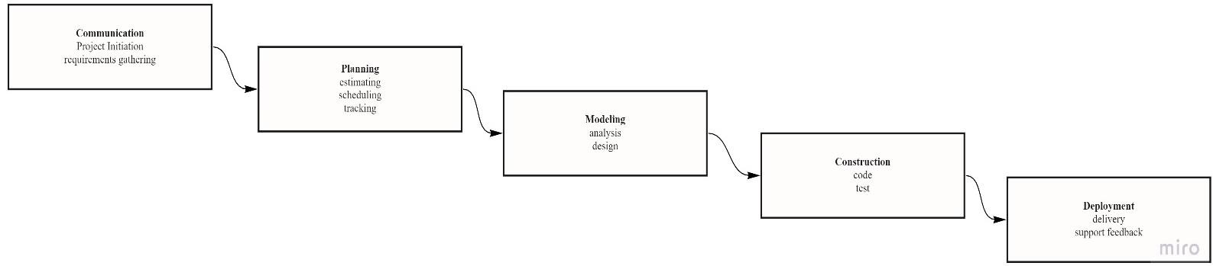

Problem Statement: To apply waterfall model of E-commerce website by following path mentioned in above figure.

Requirement Gathering:

1. Add to cart facility.

2. Cash On Delivery (COD) as well as online payment option.

3. Purchased Product feedback facility.

4. Filtering, Searching product options on homepage.

5. Wish list option.

6. Ordered product status.

7. Multiple shipping address option.

8. Viewing option where more detail of the product.

9. Enquiry for product facility.

10. Login and Sign up option, Account recovery option, Credential security, Using App without Login.

11. Update through E-mail.

Planning:

1. Work products obtained each month should be reported in monthly discussion.

2. OS should be Windows 10 / Ubuntu >=18.04 with compatible Hardware.

3. Each Team should work at least 5 hours a day 5 days in a week.

4. Documentation should be prepare in multiple languages (English, Hindi, Kanji,….).

5. Model should be prepare under 2 months.

6. Each feature construction should be done under 20 days.

7. Cost of Design and Analysis – 10,000, Cost of Construction – 20,000,

Cost of Deployment - 8,000, Additional Charges – 2,000, Cumulated Cost – 40,000

8. Final work product delivery in 1 and half year (Date decision).

Modeling: 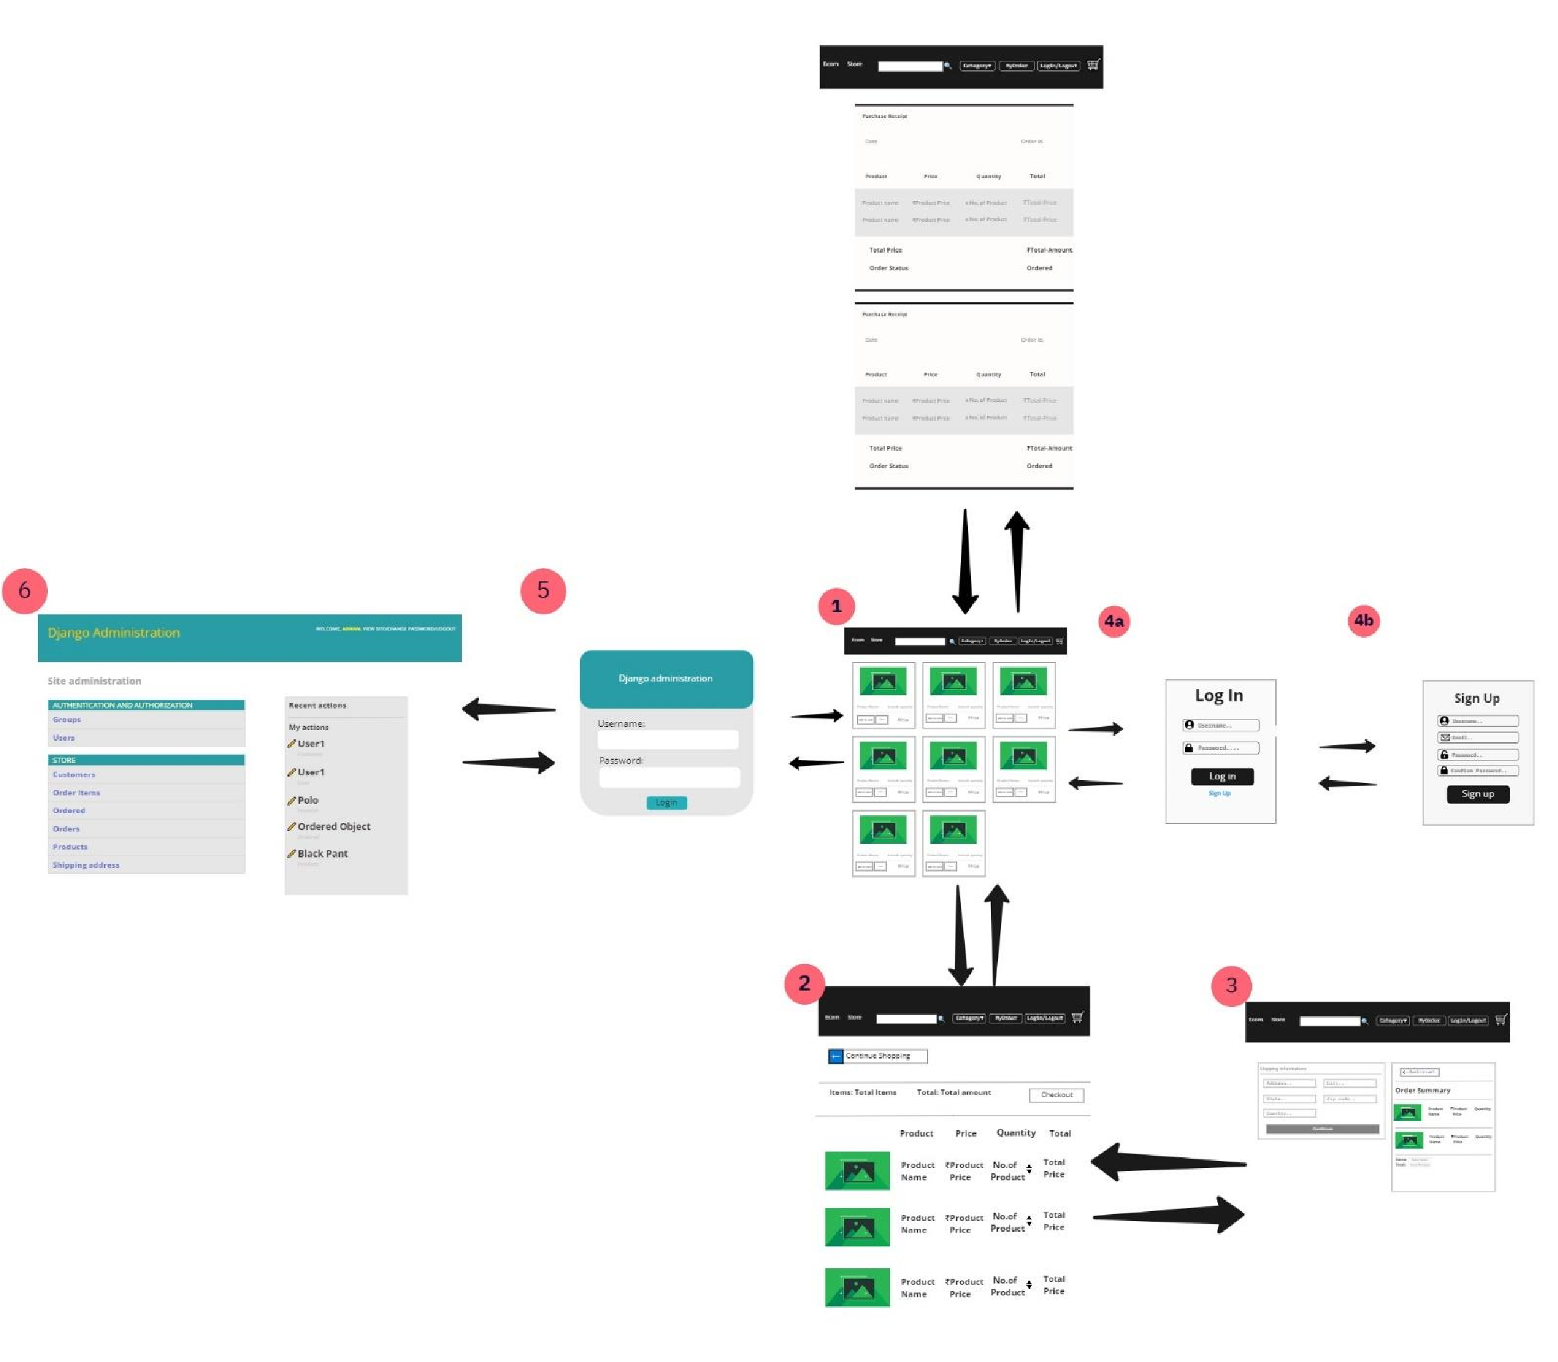

Construction:

Coding:

1. Languages to be use are Python>=3.6, Django (Python Framework) >=2.2, JavaScript ES6, React-Native (JS framework) >= 0.6, HTML5, CSS4, BootStrap4 and Database connectivity with MySQL.

2. Flow of programming: Home page →Adding Features at home page (Filtration, Searching and Viewing) → Add to Cart page → Login and Signup page → Profile Page → Transaction Page → Product Status page→ Admin Page →Adding remaining small features.

Testing: Unit Testing → Integration Testing → System Testing → Acceptance Testing.

Deployment:

1. Purchasing suitable domain name.

2. Selecting hosting server.

3. Releasing product on decided date.

Incremental model:

Incremental model is combination of systemic and linear sequential flow of Water fall model and parallel process flows. The incremental model applies linear sequences in a staggered fashion as calendar time progresses. Each linear sequence produces deliverable “increments” of software.

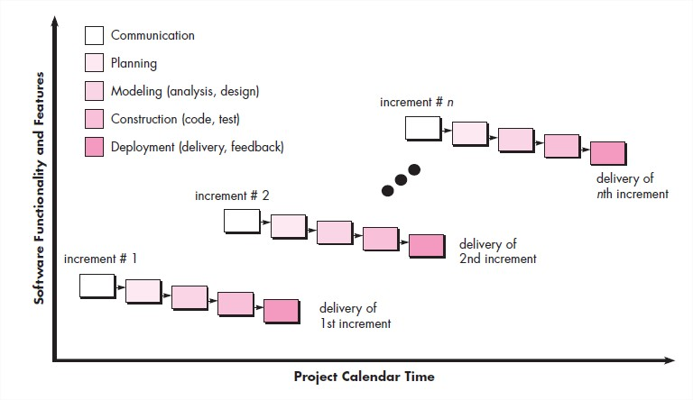

Problem Statement: To apply Incremental model on E-commerce website by following path mentioned in above figure.

Increment 1: Core product delivery

Requirement Gathering:

1. Add to cart Functionality.

2. Cash On delivery option.

3. Login and Sign Up Options.

Planning:

1. Model should be prepare under 20 days.

2. Each Team member should work at least 7 hours a day, 5 days in a week.

3. OS should be Windows 10 / Ubuntu >=18.04 with compatible Hardware.

4. I) What tasks accomplished since last meeting?

II) What issues are encountered?

III) What task will be accomplished by the next meeting?

These questions will be answered by every team members in daily short meeting of 15 minutes.

5. Each requirements constructions should be given at most 40 days.

6. Cumulated cost – 30,000.

7. Final core product should be delivered in 6 months.

Modeling:

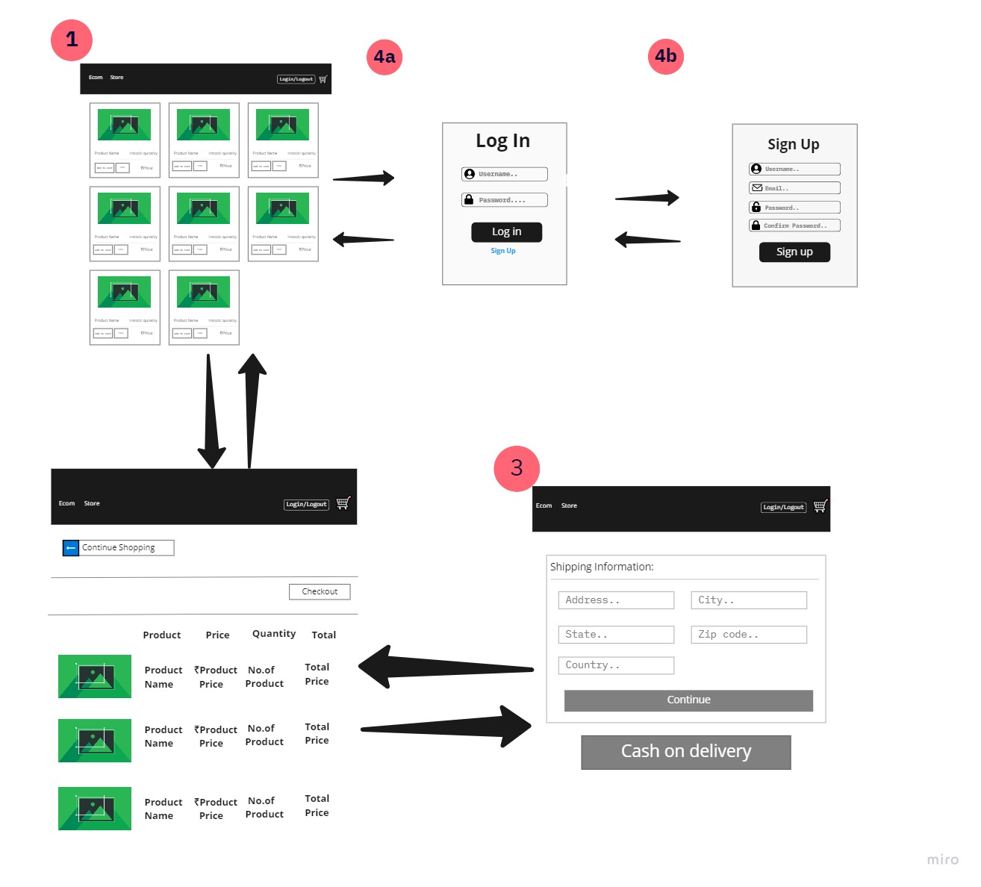

Construction:

Coding:

1. Languages to be use are Python>=3.6, Django (Python Framework) >=2.2, HTML5, CSS4, BootStrap4 and Database connectivity with dbsqlite3.

2. Flow of programming: Homepage 🡪 Cart Page 🡪 Check out page 🡪 Login page 🡪 Sign Up page.

Testing: Unit Testing → Integration Testing → System Testing → Acceptance Testing.

Deployment:

1. Purchasing suitable domain name.

2. Selecting hosting server.

3. Releasing product on decided date.

Increment 2: Fixing hidden bugs and adding important new features.

Requirement gathering:

1. Adding Search and filter features.

2. Account recovery option, Credential security and using app without login.

3. Increasing product quantity in cart page

4. Order summary in Check out page.

5. Online transaction facility.

Planning:

1. Model modification in 14-20 days.

2. Each Team member should work at least 6 hours a day, 5 days in a week.

3. Each requirements constructions should be given at most 40 days.

4. Simple documentation should be prepare in 20 days.

5. No change in team meeting.

6. Cumulated Cost - 30,000.

7. Release of increment 2 in 8 months

Modeling: Modified previous model.

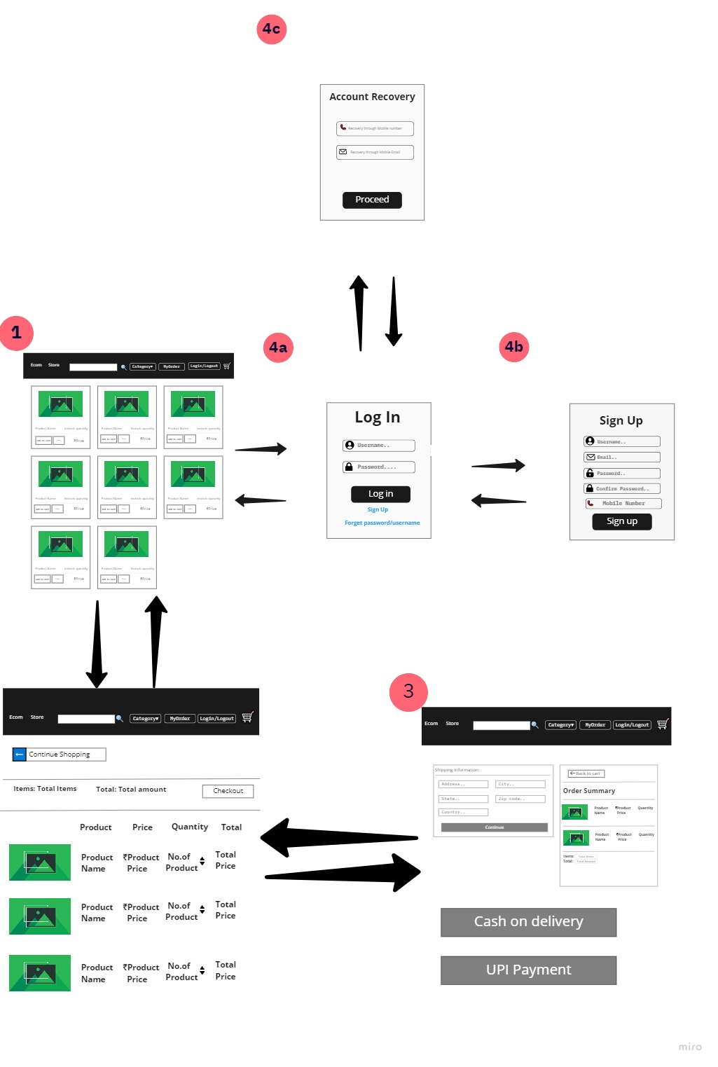

Construction:

Coding:

1. Java Script ES6 integrating with languages used in Increment 1 and Database changed to MySQL.

2. Flow of programming: Adding filtration and search options 🡪 Use of app without logging using cookies 🡪 Adding online transaction option 🡪 Account recovery option 🡪 Enhancing Security.

Testing: Unit Testing → Integration Testing → System Testing → Acceptance Testing.

Deployment:

1. Uploading code to server.

2. Releasing Increment 2.

Increment 3: Adding new features for ease of customers.

Requirement gathering:

1. Purchased Product feedback facility.

2. Wish list option.

3. Ordered product status.

4. Multiple shipping address option.

5. Viewing option where more detail of the product.

6. Enquiry for product facility.

7. Update through E-mail and Phone Number.

Planning:

1. Creating Model for Product status page at most 4 days.

2. Each Team member should work at least 5 hours a day, 5 days in a week.

3. Each requirements constructions should be given at most 40 days.

4. Documentation preparation in different languages in 40 days.

5. No change in team meeting.

6. Cumulated Cost - 30,000.

7. Release of increment 3 in 12 months.

Modeling: Model of product status page

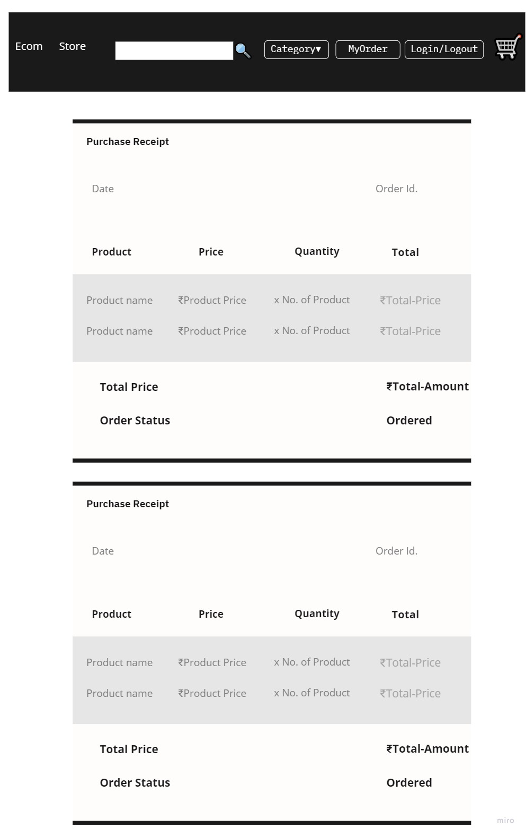

Construction:

Coding:

1. Reactive Native + languages used in Increment 2.

2. Flow of programming: Wish list option🡪 Multiple shipping address option 🡪 Viewing option 🡪 Update through Email and phone number 🡪 Product status page 🡪 Enquiry for product 🡪 Purchased Product feedback facility.

Testing: Unit Testing → Integration Testing → System Testing → Acceptance Testing.

Deployment:

1. Uploading code to server.

2. Releasing Increment 3.

Conclusion: We have successfully applied two traditional process models (Water fall and Incremental model) for development of E-commerce shopping website.